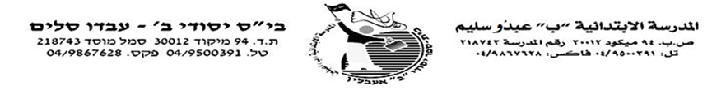

**الاسم : -------------------- الصف الأول**

**أوراق عمل حسابمراجعة للتقييم**

**الجمع والطرح حتى 10**

**1**

ش

**حل :**

**__ = 4 + 4 __= 3+ 7 __ = 2 + 5**

**__ = 0 - 1 __= 6+ 4 __ = 6 - 10**

**__ = 8 - 9 __= 3 - 8 __ = 8 + 0**

**-----------------------------------------------------------------------------------------**

**2**

-----------------------------------------------------------------------------------------------------------------

شش

شش

**أكمل :**

**7 = + 3 1 = - 2**

**10= + 9 0 = - 7**

**-----------------------------------------------------------------------------**

**--------------------------------------------------------------------------**

ش ش

ش ش

**حل :**

**34**

**___ = 5 - 5 + 4 ___ = 6 + 4 - 4**

**___ = 2 + 5 - 10 ___ = 1 + 0 + 9**

**--------------------------------------------------------------------------**

**44**

**أكمل :**

**10 = ____ + ____ 2 = ____ + ____**

**5 = ____ - ____ 6 = ____ - ____**

**---------------------------------------------------------------------------ضع إشارة > < = :**

**54**

**2 + 1 1 + 1 1 –6 4 + 3**

**1 – 8 5 + 2 2 + 2 3– 5**

**0 – 6 4 –6 0+ 10 6 + 0**

**64**

**----------------------------------------------------------------------------**

**أكتب تمريني جمع وتمريني طرح لعائلة الأعداد :**

|  |  |
| --- | --- |
| **2 5 3**  **___ = ___ + ___**  **___ = ___ + ___**  **___ = ___ - ___**  **___ = ___ - ___** | **9 0 9**  **___ = ___ + ___**  **___ = ___ + ___**  **___ = ___ - ___**  **___ = ___ - ___** |

**عملا ممتعا يا حلوين**

**حل التمارين ولون :** 